**PHOTOGRAPHIC ESSAY**

**Empowering Education: Unlocking Africa's Potential**

**Introduction:**

In this captivating photographic essay, we embark on an illuminating journey that delves deep into the profound significance of education as a catalytic force for fostering change and driving progress within the vibrant communities of Africa. Through a compelling series of evocative and thought-provoking images, our aim is to skillfully encapsulate the transformative power that education bestows upon individuals, while showcasing their unwavering determination in their tireless pursuit of knowledge and enlightenment.

As the lens focuses on various corners of African societies, we are entranced by the indomitable spirit that pervades the learning environments and permeates the lives of those who passionately engage in educational endeavors. Each photograph serves as a testament to the immense value placed on education, not merely as a means to acquire skills and knowledge, but as a formidable tool that empowers individuals to transcend barriers, overcome adversity, and create a future brimming with opportunities.

Through the lens, we capture the radiant faces of children, their eyes sparkling with curiosity and hope, as they eagerly absorb the wisdom imparted by dedicated teachers who themselves embody the embodiment of change. In humble classrooms adorned with vivid illustrations and filled with the melody of eager minds, these young learners seize every chance to broaden their horizons, recognizing education as the transformative gateway to a world of possibilities.

Beyond the confines of traditional educational settings, we turn our attention to the profound impact education has on marginalized communities. Our camera transports us to remote villages, where resilient individuals and grassroots organizations take charge of their own destiny by establishing informal learning spaces. Against all odds, they channel their passion and resourcefulness into nurturing a culture of learning, ensuring that education becomes a beacon of hope that transcends geographical and socioeconomic constraints.

These evocative images resonate with the shared stories of triumph and resilience. We witness young women defying societal norms and pursuing education, blazing a trail for future generations, and dismantling long-standing barriers to gender equality. We witness young men embracing education as a transformative force that can break the cycles of poverty and uplift their communities.

Through this photographic essay, we celebrate the collective efforts and unwavering commitment of educators, community leaders, and learners who tirelessly champion the cause of education. Their journey is one of unwavering determination, where obstacles are transformed into stepping stones, and knowledge becomes the elixir that nurtures and uplifts entire communities.

In the profound and emotive moments captured within these images, we invite viewers to reflect upon the far-reaching implications of education in Africa and its capacity to fuel progress, foster sustainable development, and empower individuals to become change agents within their communities. It is a visual narrative that speaks volumes about the transformative power of education, shedding light on the unwavering human spirit and resilience that continues to drive Africa forward on its path to a brighter future.

Photo 1:

Title: Bright Futures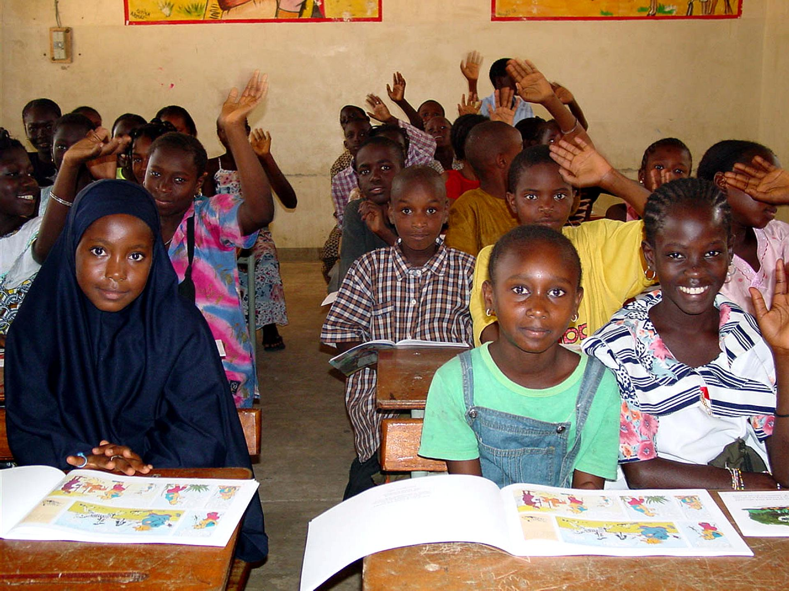

Description: In this captivating photograph, we are drawn into a vibrant classroom setting, where a diverse group of children eagerly immerse themselves in the wonders of learning. Their youthful faces radiate with infectious smiles, mirroring the profound hope and boundless enthusiasm that education ignites within them. It is in this very moment that the transformative power of education reveals itself, painting a vivid picture of the limitless possibilities it holds in shaping a brighter future for the promising youth of Africa.As we delve deeper into the image, the sheer joy and curiosity exuded by these young learners become palpable. Each child embodies the embodiment of potential, their eyes twinkling with an insatiable thirst for knowledge. They are active participants in their own educational journey, actively engaging with their teachers and peers, eagerly absorbing the wealth of information and ideas that surround them. It is through this dynamic exchange that they begin to cultivate critical thinking skills, nurture their creativity, and develop a deep-rooted sense of self-belief.

Photo 2:

Title: Books Open Doors



Description: This captivating image captures a young girl fully engrossed in a book, serving as a powerful symbol of the profound impact that education and literacy have on individuals. It symbolizes the key role that knowledge plays in empowering individuals and opening up a world of opportunities. The photograph beautifully illustrates how education fuels curiosity, imagination, and a lifelong pursuit of learning.

In this image, the young girl's absorbed demeanor represents the transformative power of literacy, highlighting its ability to expand horizons and shape destinies. Through education, she gains the tools and skills necessary to navigate the complexities of the world, fostering her personal growth and development.

By immersing herself in the pages of a book, the girl exemplifies the immense value of literacy in enabling critical thinking, creativity, and self-expression. This evocative photograph serves as a reminder of the profound impact that education has on individuals and societies, emphasizing the importance of fostering literacy to build a brighter and more inclusive future for all.

Photo 3:

Title: Dedicated Teachers



Description: This captivating image captures the essence of a passionate teacher standing confidently in front of a blackboard, radiating inspiration and guidance to a classroom full of students. It serves as a powerful representation of the unwavering dedication and commitment that educators possess in nurturing the minds of the next generation.

The photograph showcases the profound impact teachers have on their students' educational journey. With enthusiasm and expertise, the teacher captivates the attention of the students, fostering a thirst for knowledge and igniting their curiosity. The blackboard, adorned with educational material, symbolizes a canvas where the teacher imparts valuable lessons and impels intellectual growth.

The image encapsulates the transformative power of education and the crucial role that teachers play in shaping the future. It demonstrates how educators selflessly invest their time and energy to empower young minds, equipping them with the tools and skills they need to succeed in their educational pursuits and beyond.

Through this image, we recognize and celebrate the invaluable contributions of passionate teachers who devote themselves to nurturing and inspiring students, fostering a love for learning that will guide them throughout their lives.

Photo 4:

Title: Access to Education

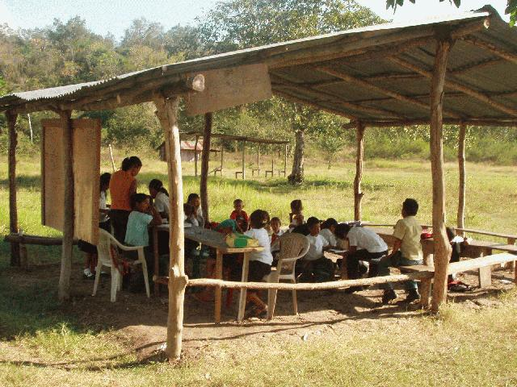

Description: This compelling image depicts a school building situated in a rural area, serving as a powerful symbol of the crucial significance of ensuring equitable access to quality education for individuals, regardless of their geographic location or socioeconomic background. It underscores the importance of bridging the educational divide and creating opportunities for learning in underserved communities.

The photograph highlights the transformative potential of education in rural areas, where access to educational resources may be limited. It emphasizes the essential role of providing students in these regions with the tools, knowledge, and opportunities they need to thrive and reach their full potential.By showcasing a school building in a rural setting, the image calls attention to the need for inclusive educational policies and initiatives that address the unique challenges faced by these communities. It serves as a reminder of the profound impact that education can have in breaking the cycle of poverty and empowering individuals to create a brighter future for themselves and their communities.This powerful photograph urges us to recognize that every individual, regardless of their location or socioeconomic background, deserves access to quality education. It prompts us to work towards fostering educational equity, ensuring that no one is left behind in the pursuit of knowledge and opportunities for growth.

Photo 5:

Title:Digital Revolution

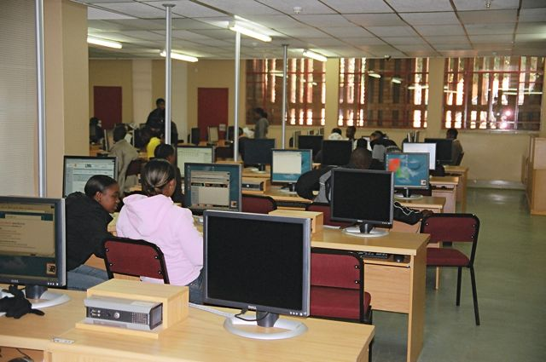

Description: A compelling photograph captures the essence of students in a classroom setting, actively engaged in utilizing technology. This powerful image serves as a reminder of the profound importance of integrating digital tools to enhance learning experiences and bridge the digital divide prevalent in African communities.

Within the frame, we witness a vibrant scene where students from diverse backgrounds are immersed in the world of digital learning. Their eager faces reflect the excitement and enthusiasm that arises from accessing educational resources previously beyond their reach.

The photograph underscores the transformative potential of technology in empowering African students. By embracing digital tools, these young minds are not only expanding their knowledge but also developing essential skills for the future. Through this integration, educational barriers are dismantled, and students are equipped to compete on a global scale.

Furthermore, the image highlights the strides being made in bridging the digital divide in African communities. It symbolizes the collective efforts of educators, policymakers, and organizations that are working tirelessly to ensure equal access to technology, creating a level playing field for all learners.

In this photograph, we witness the emergence of a new era, where the fusion of education and technology transcends boundaries, unlocking boundless possibilities for African students and ultimately paving the way for a brighter future..

Photo 6:

Title: Women's Empowerment

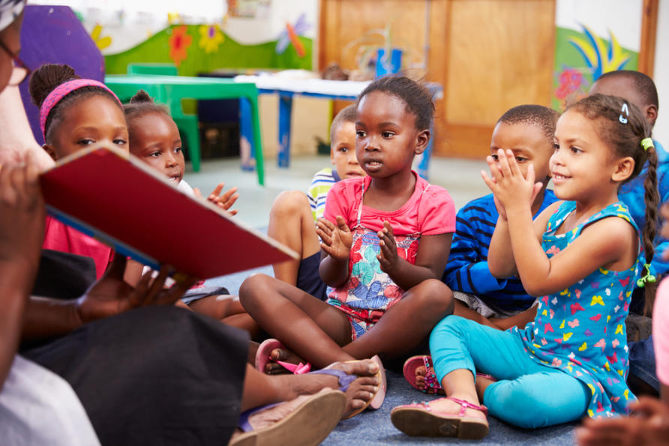

Description: A captivating image captures the essence of young girls attending school, boldly embracing education as a means to challenge gender norms and empower themselves. This empowering photograph celebrates the transformative impact of education on promoting gender equality in African society.

In this inspiring visual, we witness a scene filled with resilience and determination as these young girls break through societal barriers. Their radiant smiles reflect their newfound confidence and sense of agency, emphasizing the pivotal role education plays in empowering girls and transforming their lives.

The photograph symbolizes a profound shift in African society, where education becomes the catalyst for dismantling gender stereotypes and creating opportunities for girls. It showcases the collective efforts of individuals, communities, and organizations working tirelessly to ensure every girl's right to education.

Furthermore, the image captures the ripple effect of empowering girls through education. As these girls grow into confident, educated women, they become catalysts for change in their communities, challenging traditional gender roles and inspiring future generations.

In this photograph, we celebrate the triumph of education over gender inequality, envisioning a future where every girl in Africa has equal access to education, enabling them to realize their full potential and contribute to the progress and development of their societies.

Photo 7:

Title: Community Support

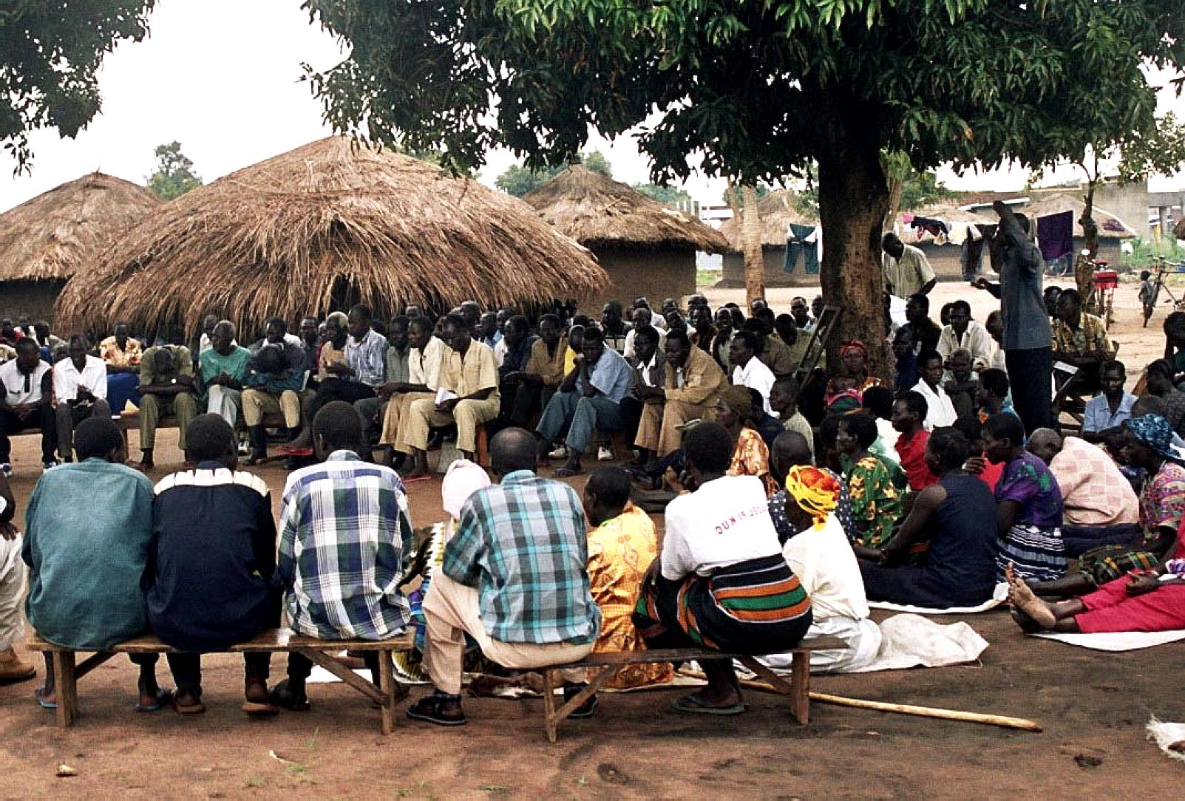

Description: A captivating image encapsulates a community coming together around a makeshift outdoor classroom, exemplifying the power of collective effort and support in overcoming educational challenges and fostering a vibrant culture of learning.

Within the frame, we witness a heartwarming scene where people from diverse backgrounds gather under the open sky, united in their commitment to education. The photograph showcases the resilience and determination of the community, as they create an inclusive space for learning, even in the face of limited resources.

The image serves as a testament to the belief that education is not an individual pursuit but a collective responsibility. It highlights the spirit of collaboration and solidarity as community members join hands to create an environment where knowledge can flourish.

Moreover, the photograph captures the transformative impact of community engagement on education. By rallying together, the community demonstrates its unwavering support for learners, fostering a culture that values and prioritizes education as a means of empowerment and progress.

In this powerful visual, we witness the collective will to overcome educational barriers. It serves as an inspiration, reminding us of the importance of fostering inclusive learning environments and nurturing a sense of community ownership in the pursuit of education.

Ultimately, the photograph encapsulates the resilience and determination of the community, symbolizing the collaborative efforts needed to ensure that education becomes a beacon of hope and opportunity for all, transcending the limitations posed by challenging circumstances.

Conclusion:

This photographic essay serves as an impactful testament, shedding light on the profound significance of education as an inherent and indispensable right within African communities. Through a compelling visual narrative, it showcases the resilience, unwavering determination, and boundless potential of individuals who relentlessly strive for knowledge amidst various challenges and adversities.

The images presented vividly capture the transformative power of education, acting as a poignant reminder that it is the key to unlocking Africa's true potential. By prioritizing and valuing education as a fundamental right, society can create an environment that empowers and uplifts its future leaders, innovators, and change-makers.

One cannot overlook the fundamental truth that education is a catalyst for change. It equips individuals with the necessary skills, knowledge, and tools to break free from the shackles of poverty, inequality, and limited opportunities. These images serve as testaments to the fact that education is a powerful force capable of transcending socioeconomic barriers, cultural boundaries, and systemic injustices, enabling individuals to create a brighter and more prosperous future for themselves and their communities.

By highlighting the importance of equitable access to education, this photographic essay underscores the urgent need for comprehensive and inclusive educational systems throughout Africa. It emphasizes the critical role of governments, policymakers, and stakeholders in ensuring that education is accessible to all, irrespective of gender, socioeconomic background, or geographical location.

Furthermore, these images not only capture the transformative impact of education on individuals but also underscore the broader benefits for society as a whole. Education fuels innovation, fosters critical thinking, and nurtures a generation of individuals who are equipped to address the complex challenges facing their communities. It ignites a spark of inspiration and empowers individuals to challenge the status quo, driving sustainable development, and creating positive change at local, national, and continental levels.

In conclusion, this photographic essay eloquently portrays the profound significance of education as a fundamental right and a potent tool for transformation in African communities. It serves as a resounding call to action, urging society to prioritize education and ensure equitable access for all. By doing so, we can unlock the full potential of Africa's future leaders, innovators, and change-makers, thereby paving the way for a brighter, more prosperous, and inclusive continent.